SLANGFIELD PAGE TEMPLATE

HOME PAGE TEMPLATE
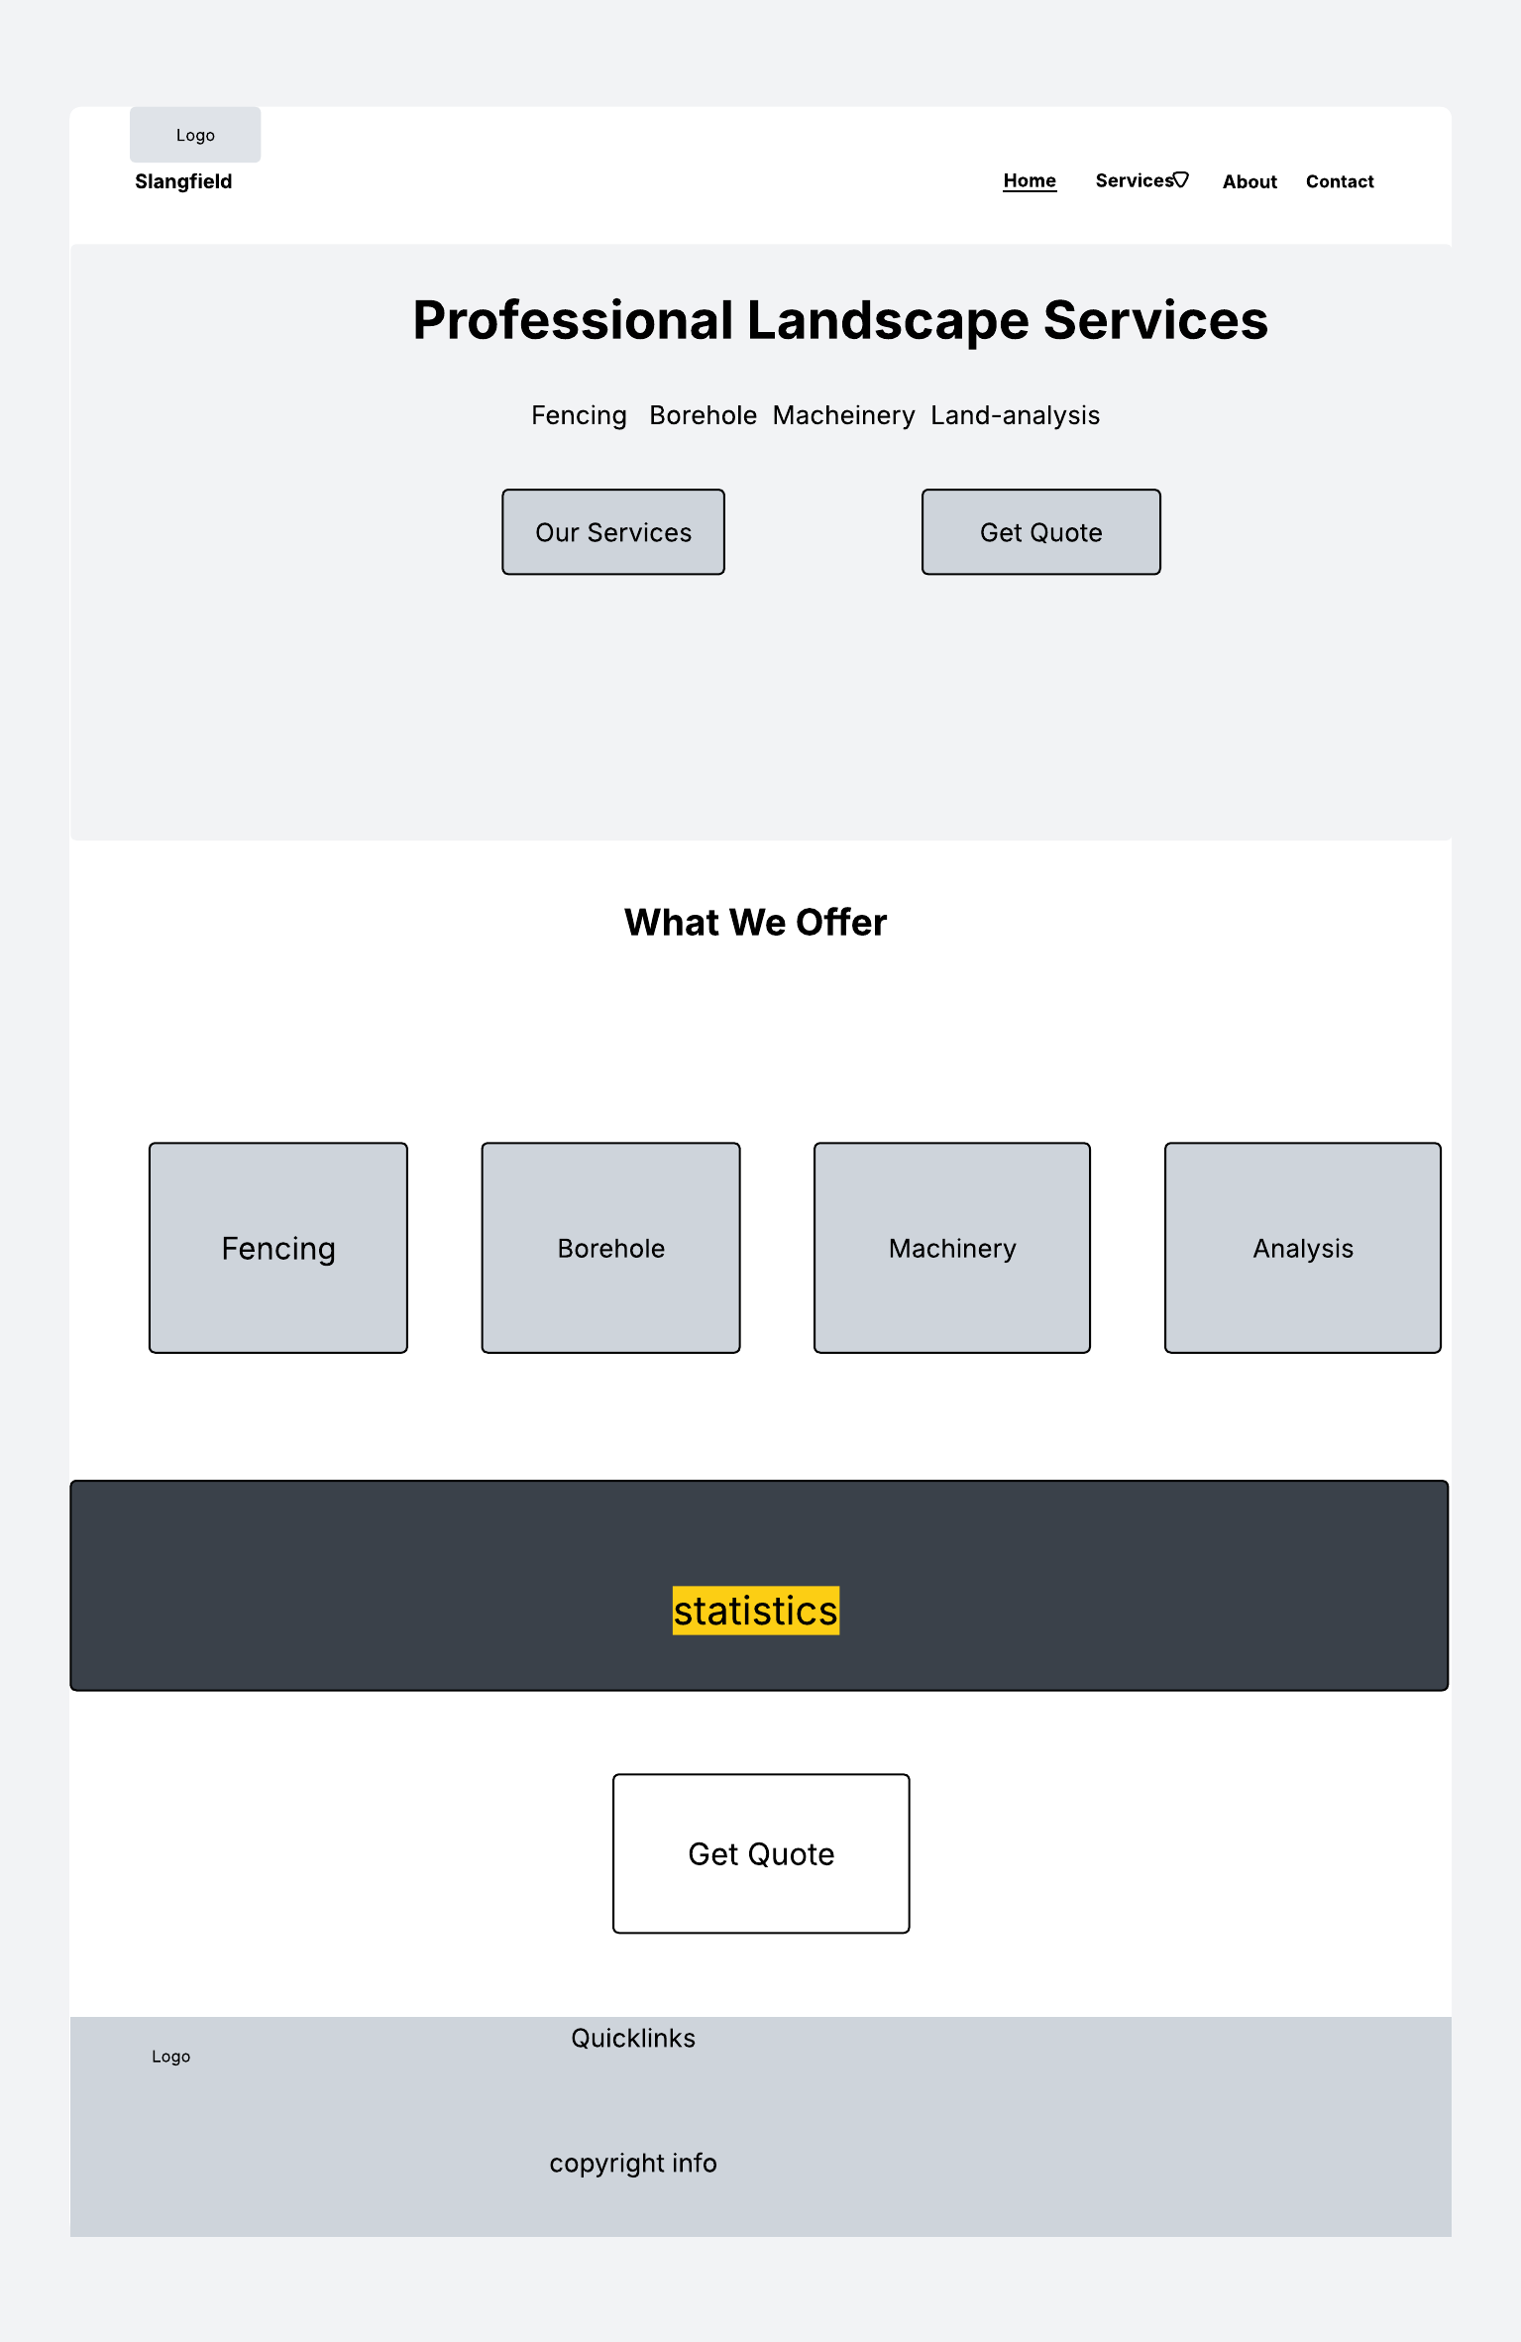
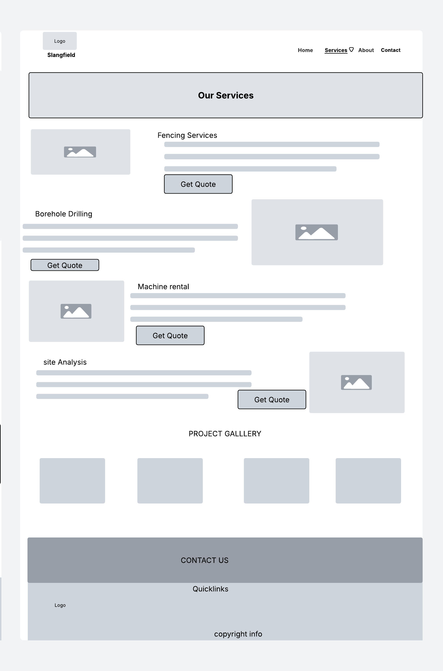
SERVICE PAGE TEMPLATE
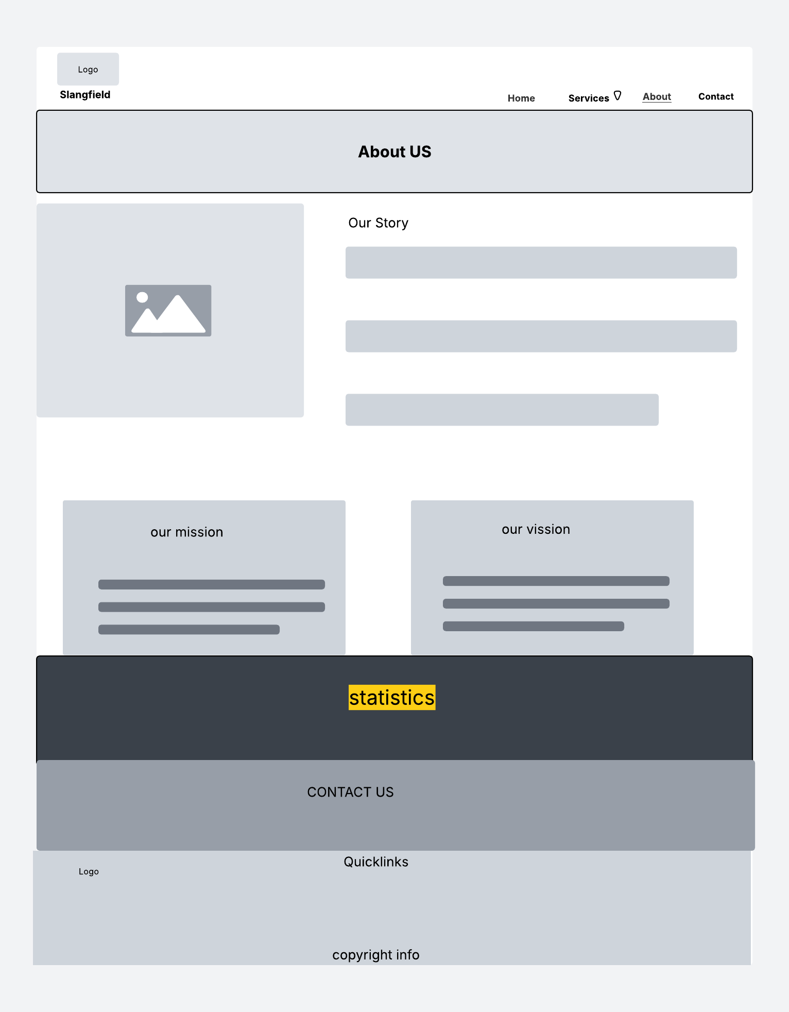
ABOUT PAGE TEMPLATE

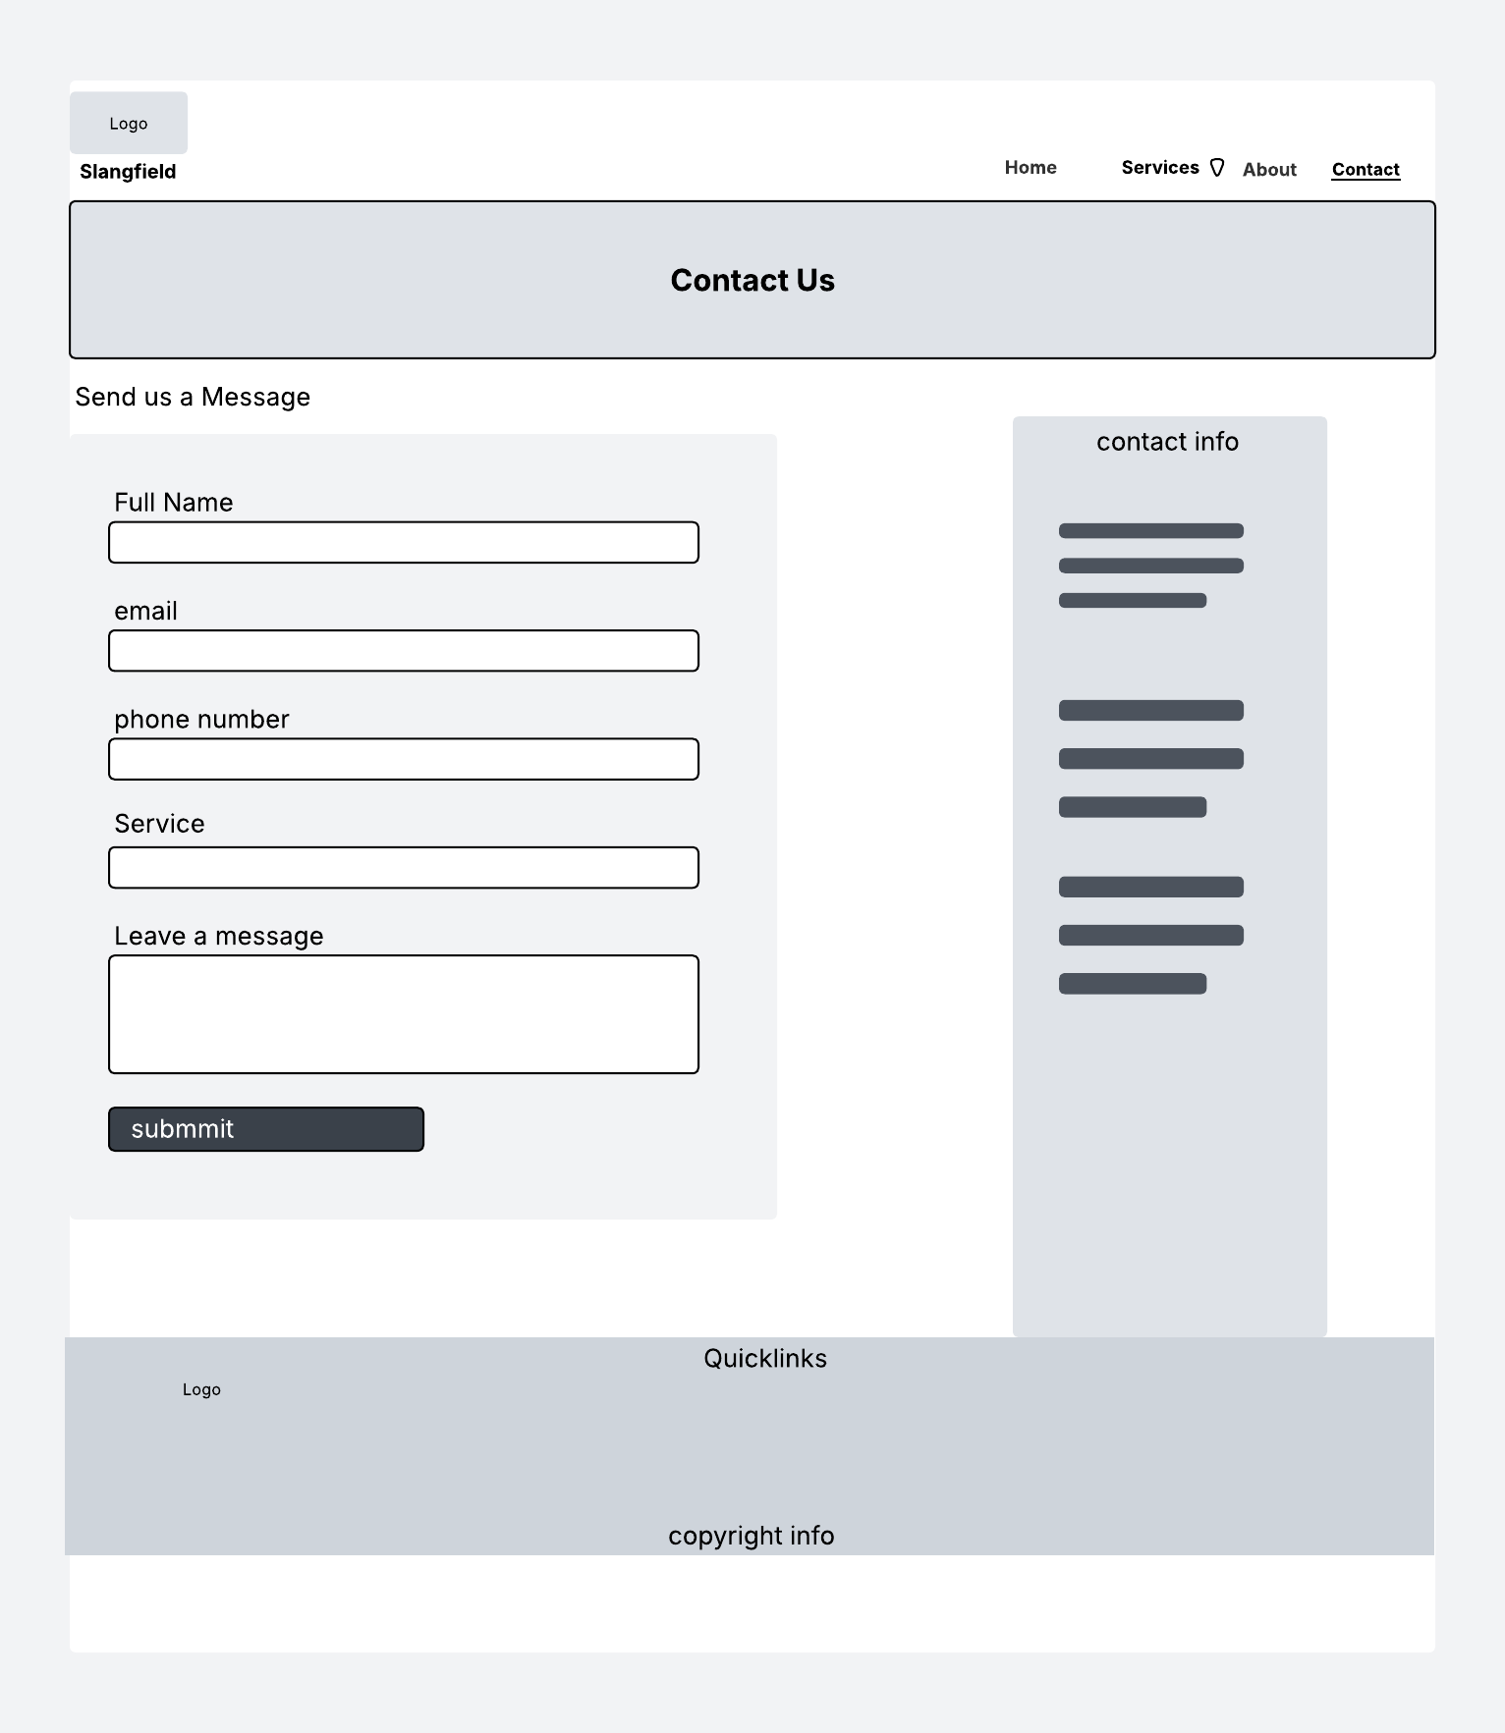
CONTACT PAGE TEMPLATE

